Stage 4 – Never again? I lied.
COURSE DESIGNER: Delmarva (remixed)
SCORING: Comstock 22 rounds.
TARGETS: 10 cardboard targets, 2 steel targets
SCORED HITS: 2 Best hits per carboard will be scored.

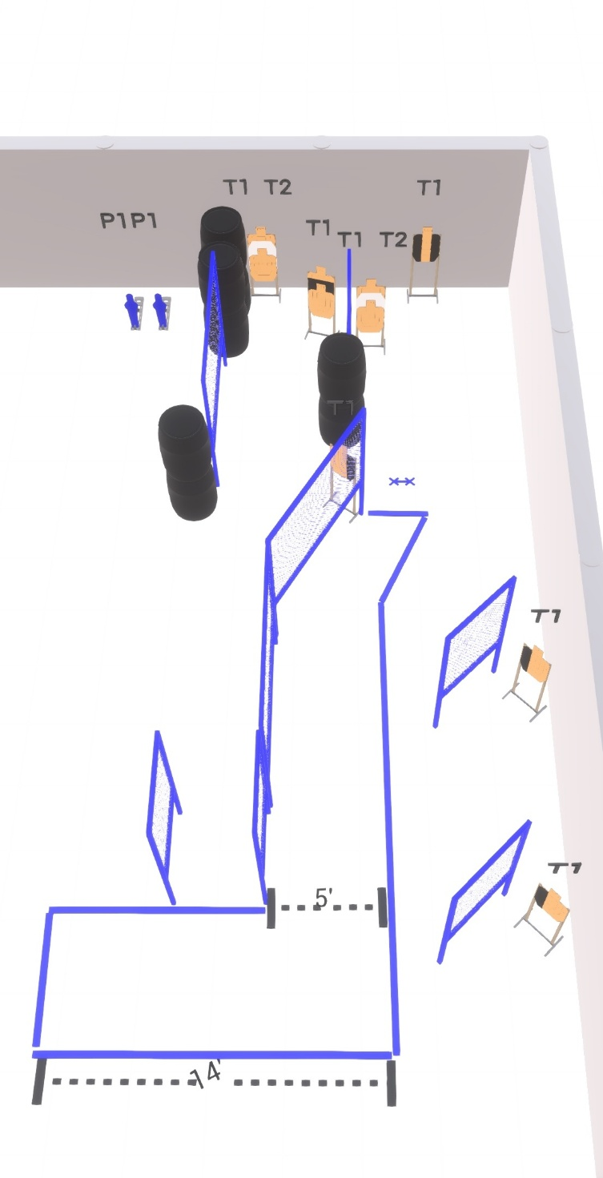

Written Stage Briefing:

Stage 4 – Never again? I lied. - is a 22 round, 110 point, Comstock Course. There are 10 cardboard targets and 2 steel targets.

Starting feet on Xs.
Handgun is loaded and holstered, wrists below belt.
PCC is loaded held in both hands, stock on belt.

On the audible start signal, engage targets from within the shooting area.

USPSA / NROI Range Commands:
- Make Ready
- Are you ready?
- Standby
- If finished, unload and show clear
- If clear, hammer down and holster (Handgun)
If clear, hammer down and flag (PCC)
If clear, cylinder closed and holster (Revolver)
- Range is clear

Setup Notes:
12 Single Wall Stands
2 Double Wall Stands
4 Full Walls
4 Half Walls
10 Target stands / 20 target sticks
2 Small Popper + bases
8+ Barrels

